**Project Development Phase**

**Model Performance Test**

|  |  |
| --- | --- |
| Date | 9 November 2023 |
| Team ID | PNT2022TMIDxxxxxx |
| Project Name | Project - ECOMMERCE SHIPPING PREDICTION USING MACHINE LEARNING |
| Maximum Marks | 10 Marks |

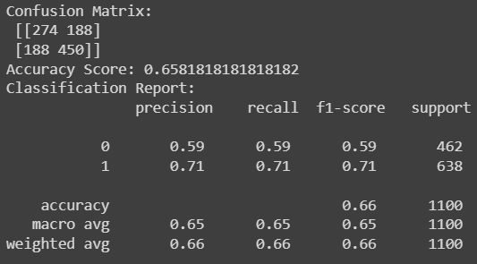**Model Performance Testing:**

|  |  |  |  |
| --- | --- | --- | --- |
| **S.No.** | **Parameter** | **Values** | **Screenshot** |
|  | Metrics | **Regression Model:** MAE: 0.3418181818181818 ,  MSE: 0.3418181818181818,  RMSE: 0.5846521887568555,  R2 score: -0.4031945066427822  **Classification Model:** Confusion Matrix: [[274 188]  [188 450]], Accuray Score: 0.6581818181818182  & Classification Report: |  |
|  | Tune the Model | Validation Method: Train-Test Split |  |